EXP : 5  DATE: | SIGN UP FORM – POST METHOD

AIM:
To develop a Java Servlet program that handles user input from a sign-up form using the POST method, retrieves the submitted data (such as first name, last name, date of birth, address, and gender), and displays the details back to the user in a structured HTML format.

CODE:
SignUp.html:
<!DOCTYPE html>
<html lang="en">
<head>
<meta charset="ISO-8859-1">
<title>Sign Up Form</title>
</head>
<body>
<form action="/faisal_104/SignupDetails" method="post">
<label for="fname">First Name:</label>
<input type="text" id="fname" name="fname">
<br>
<br>
<label for="lname">Last Name:</label>
<input type="text" id="lname" name="lname">
<br>
<br>
<label for="dob">Date of Birth:</label>
<input type="date" id="dob" name="dob">
<br>
<br>
<label>Gender:</label>
<input type="radio" id="male" name="gender" value="male">
<label for="male">Male</label>
<input type="radio" id="female" name="gender" value="female">
<label for="female">Female</label>
<br>
<br>
<label for="address">Address:</label>
<textarea id="address" name="address"></textarea>
<br>
<br>
<br>
<br>
<input type="submit" value="Sign Up">
</form>
</body>
</html>

SignupDetails.java:
package com.faisal.servlet;

import java.io.IOException;
import java.io.PrintWriter;

import javax.servlet.ServletException;
import javax.servlet.annotation.WebServlet;
import javax.servlet.http.HttpServlet;
import javax.servlet.http.HttpServletRequest;
import javax.servlet.http.HttpServletResponse;

/**
* Servlet implementation class SignupDetails
*/
@WebServlet("/SignupDetails")
public class SignupDetails extends HttpServlet {
private static final long serialVersionUID = 1L;

/**
* @see HttpServlet#HttpServlet()
*/
public SignupDetails() {
super();
}

/**
* @see HttpServlet#doGet(HttpServletRequest request, HttpServletResponse response)
*/
protected void doGet(HttpServletRequest request, HttpServletResponse response) throws ServletException, IOException {

}

/**
* @see HttpServlet#doPost(HttpServletRequest request, HttpServletResponse response)
*/
protected void doPost(HttpServletRequest request, HttpServletResponse response) throws ServletException, IOException {
String fname = request.getParameter("fname");
String lname = request.getParameter("lname");
String dob = request.getParameter("dob");
String gender = request.getParameter("gender");
String add = request.getParameter("address");

PrintWriter p = response.getWriter();
p.println("First Name: " + fname );
p.println("Last Name: " + lname );
p.println("DOB: " + dob );
p.println("Gender: " + gender );
p.println("Address: " + add);
}
}

OUTPUT:

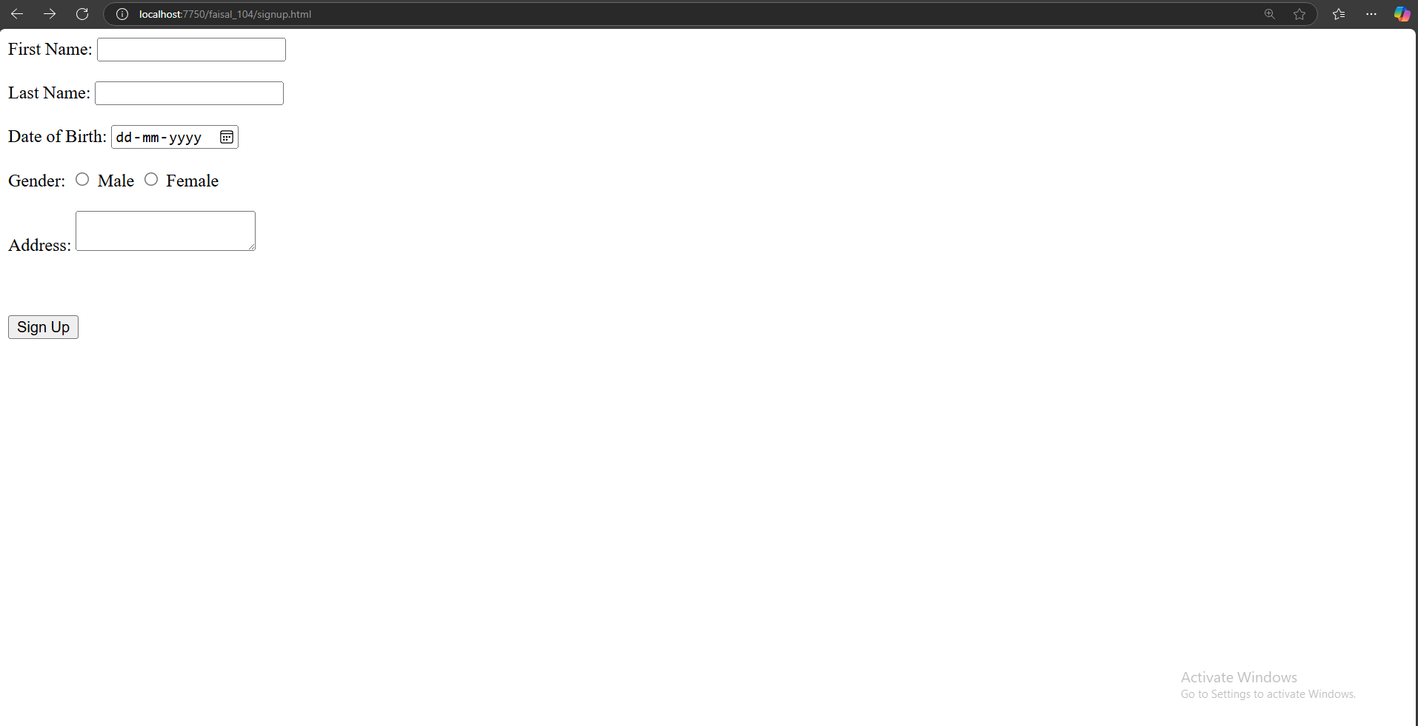



RESULT:
Handling signup form using the post method has been Executed Successfully.

